PROJECT DESIGN PHASE – II

Data Flow Diagram

|  |  |
| --- | --- |
| Date | 6.11.2022 |
| Team ID | PNT2022TMID46328 |
| Project Name | Estimation of crop yield using data analytics. |
| Maximum Marks | 4 Marks |

**DATA FLOW DIAGRAM**

A Data Flow Diagram (DFD) is a traditional visual representation of the information flows within a system. A neat and clear DFD can depict the right amount of the system requirement graphically. It shows how data enters and leaves the system, what changes the information, and where data is stored.

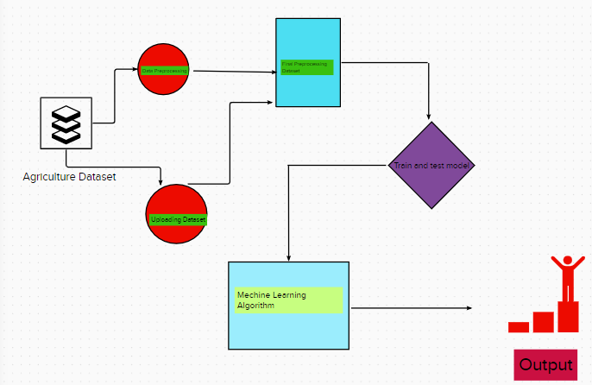

**USER STORIES**

| **User Type** | **Functional Requirement (Epic)** | **User Story Number** | **User Story / Task** | **Acceptance criteria** | **Priority** | **Release** |
| --- | --- | --- | --- | --- | --- | --- |
| Customer (Mobile user) | Registration | USN-1 | As a user, I can register for the application by entering my email, password, and confirming my password. | I can access my account / dashboard | High | Sprint-1 |
|  |  | USN-2 | As a user, I will receive confirmation email once I have registered for the application | I can receive confirmation email & click confirm | High | Sprint-2 |
|  |  | USN-3 | As a user, I can register for the application through gmail or facebook | I can register & access the dashboard with Facebook Login | Medium | Sprint-2 |
|  | Login | USN-4 | As a user, I can log into the application by entering email & password | I can login to the application | High | Sprint-1 |
|  | Dashboard | USN-5 | Go to dashboard and refer the content about our project | I can read instructions also and the home page is user-friendly. | Low | Sprint-1 |
|  | Upload Dataset | USN-6 | As a user, I can able to input the agricultural datasets to the application | As a user, I can able to input the agricultural datasets to the application | High | Sprint-3 |
|  | Exploratory  Data Analysis | USN-7 | As a user I can able to get the recognised datasets as output from the agricultural datasets. | I can access the Exploratory Data Analysis- (Exploratory Data Analysis, or EDA, is the machine learning)  Understanding the patterns and trends in the data is the goal of data  exploration. All of the useful insights are drawn at this point, and the relationships between the  variables are recognized. | High | Sprint-3 |
|  | Build a ML model | USN-8 | As a user, I will train and test the datasets obtained from the agricultural datasets as input to get the maximum accuracy of output. | The Machine Learning Model is built using all of  the insights and patterns discovered during Data Exploration. The data set is always separated  into two parts, training data and testing data, at this stage. The model will be built and analyzed using the training data. The model's logic is based on the Machine Learning  Algorithm that is currently in use. | Low | Sprint-4 |
|  | Predict | USN-9 | As a user I can able to predict the model and then it is used to make predictions after it has been validated and modified. | I can able to predict the. Crop yield production based on user inputs and it is used to produce the accurate output | High | Sprint-3 |
| Customer (Web user) | Login | USN-10 | As a user, I can use the application by entering my email, password. | I can access my account | Medium | Sprint-4 |
| Customer Care Executive | Dashboard | USN-11 | upload the image | Recognize and get the output | High | Sprint-1 |
| Administrator | Security | USN-12 | updated the features | checking the security | Medium | Sprint-2 |